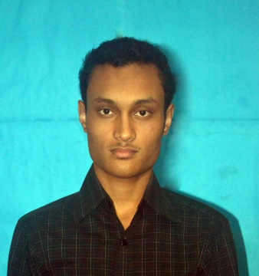

**Arnab Barua**

2/5 C&B Colony,

Dewan Bazar, Chittagong

**Phone (Mob) :** +8801820191166

**E-Mail :** <arnabjitu@gmail.com>

**Career Objective**

To succeed in an environment of growth and excellence and earn a job which provides me work satisfaction and self development and helps me to achieve personal as well as organizational goals.

**Academic Qualifications**

|  |  |  |  |  |  |
| --- | --- | --- | --- | --- | --- |
| **Year Completed** | **Institution/Board Name** | **Degree** | **Group/ Department** | **Scale** | **CGPA** |
| 2008 | Chittagong | S.S.C. | Science | 5.00 | 5.00 |
| 2010 | Chittagong | H.S.C. | Science | 5.00 | 4.90 |
| 2017 | Chittagong University of Engineering & Technology (CUET) | B.Sc. (Engg.) | CSE | 4.00 | 2.91 |

**Technical Qualifications**

**Programming languages :** C, C#, PHP, MATLAB

**Platform :** Windows

**IDEs :** Microsoft Visual Studio 2015, CodeBlocks

**Framework :** .NET

**GUI framework :** WPF

**Database :** MySQL, Microsoft SQL

**Web Programming :** HTML, JavaScript, JQuery, ASP.NET

**Programming Skill**

I have solved 50+ problems on UVA Online Judge (<http://uhunt.felix-halim.net/id/98355>)

**Project Work Experience**

* **Online admission processing system (Database management course project)**

**Tools:** PHP, HTML, CSS, JavaScript, MySQL

**Supervised by:** Mr. Tauhidul Alam, Assistant Professor, Department of CSE, CUET

* **Enterprise level Database querying (while doing industrial attachment)**

**Tools :** ASP.NET, C#, Microsoft SQLServer

* **Restaurant management software (Software engineering course project)**

**Tools :** WPF,C#,Microsodt SQLServer

**Other Involvements and Interests**

* Interested at working on .NET Framework and developing cross platform software and web application.

**Personal Strength**

* Ability to work with team as well as individually
* Self-confident, self-motivated.

**Personal Details**

* **Full Name :** Arnab Barua
* **Father’s Name :**  Anjan Barua
* **Mother’s Name :** Indira Barua
* **Date of Birth :** 30 December, 1992
* **Permanent Address :** Mohazer Para, Word No : 9,

Cox’s Bazar Pourashava, Cox’s Bazar

* **Present Address :** 2/5 C&B Colony, Dewan Bazar, Chittagong
* **Religion :** Buddhism
* **Nationality :** Bangladeshi
* **Marital Status :** Unmarried
* **Sex :** Male
* **Language :** Bangla, English (Written & Oral)

**References**

**Anick Chowdhury**

Sr. Software Engineer at Nexa Bangladesh

Email: [anickchowdhury@gmail.com](mailto:anickchowdhury@gmail.com)

**Declaration**

I do hereby declare that the above information is true to the best of my knowledge.



**(Signature)**